Task Description:
Set up minikube at your local and explore creating namespaces (Go through official documentation).
Solution:

Step-1:Create EC2 Instance(used m7i-flex.large ,t2.medium not available for free tire account )
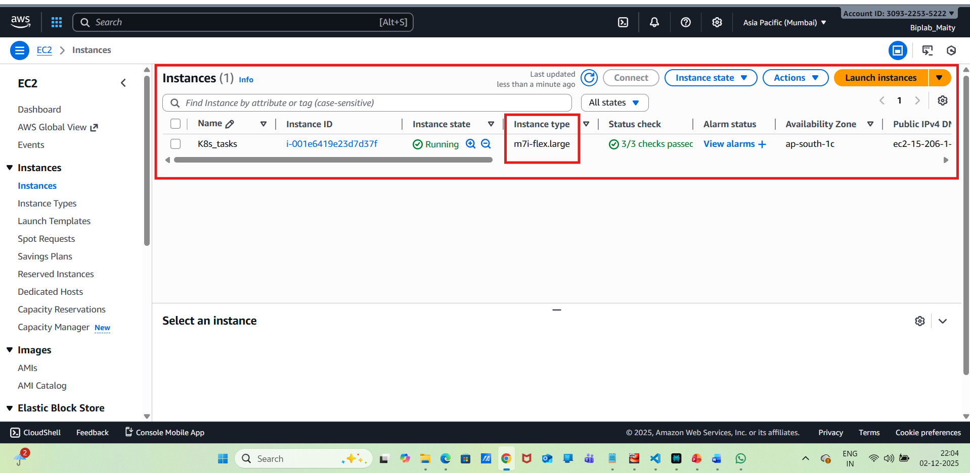

Step-2:Install Docker on EC2
sudo apt update -y
sudo apt install docker.io -y
sudo usermod -aG docker $USER
sudo usermod -aG docker ubuntu
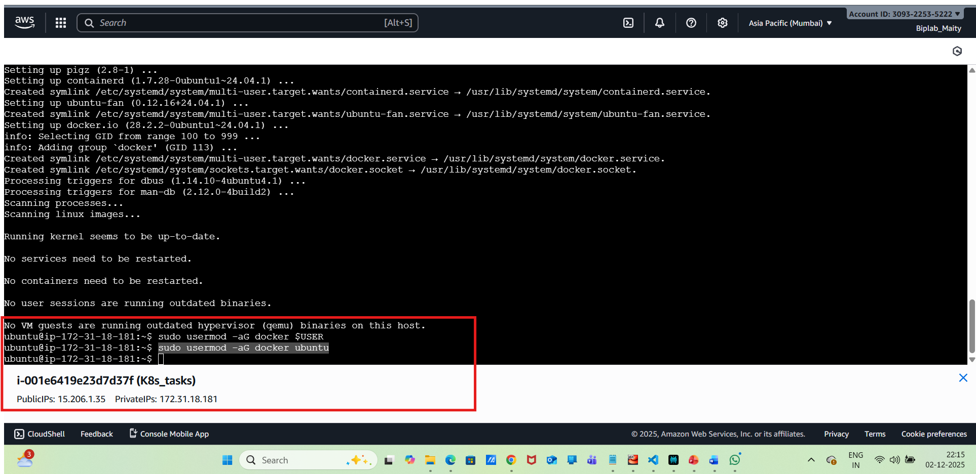
Then, need to log out from EC2 and log back in and trigger the below command

groups command
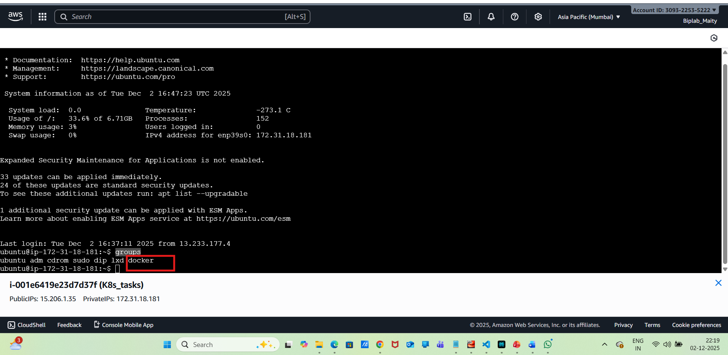
Step-3:Install Kubectl
sudo apt-get install -y apt-transport-https ca-certificates curl
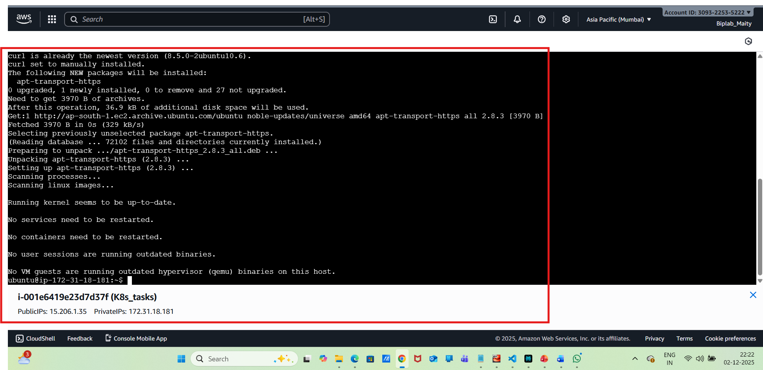
Then need to download the binary used below commands
curl -LO "https://dl.k8s.io/release/$(curl -L -s https://dl.k8s.io/release/stable.txt)/bin/linux/amd64/kubectl"
sudo install -o root -g root -m 0755 kubectl /usr/local/bin/kubectl

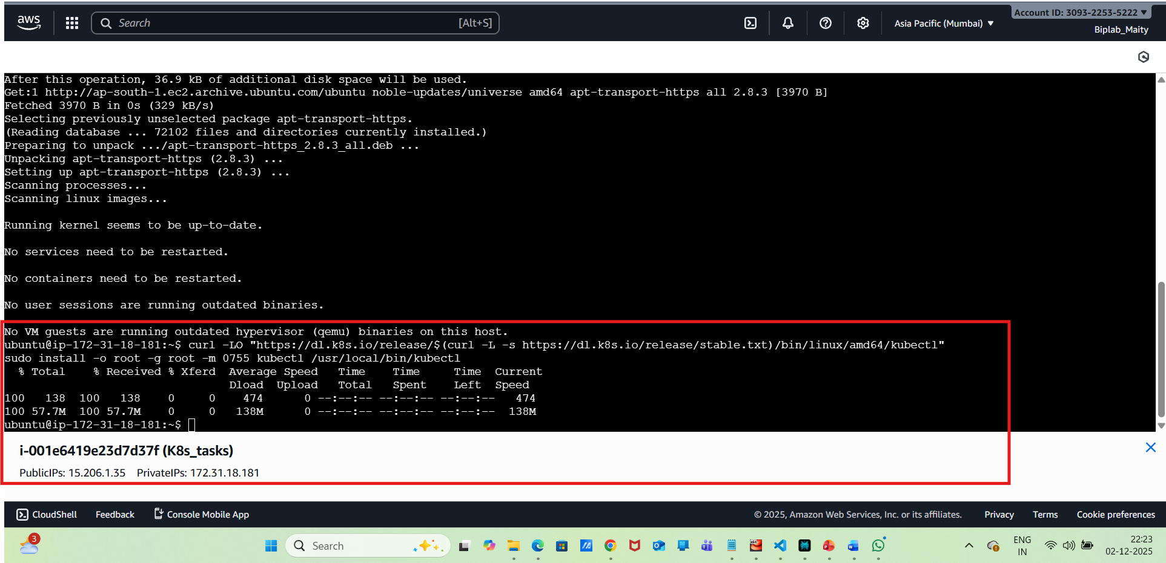
Verify the kubectl version
kubectl version --client

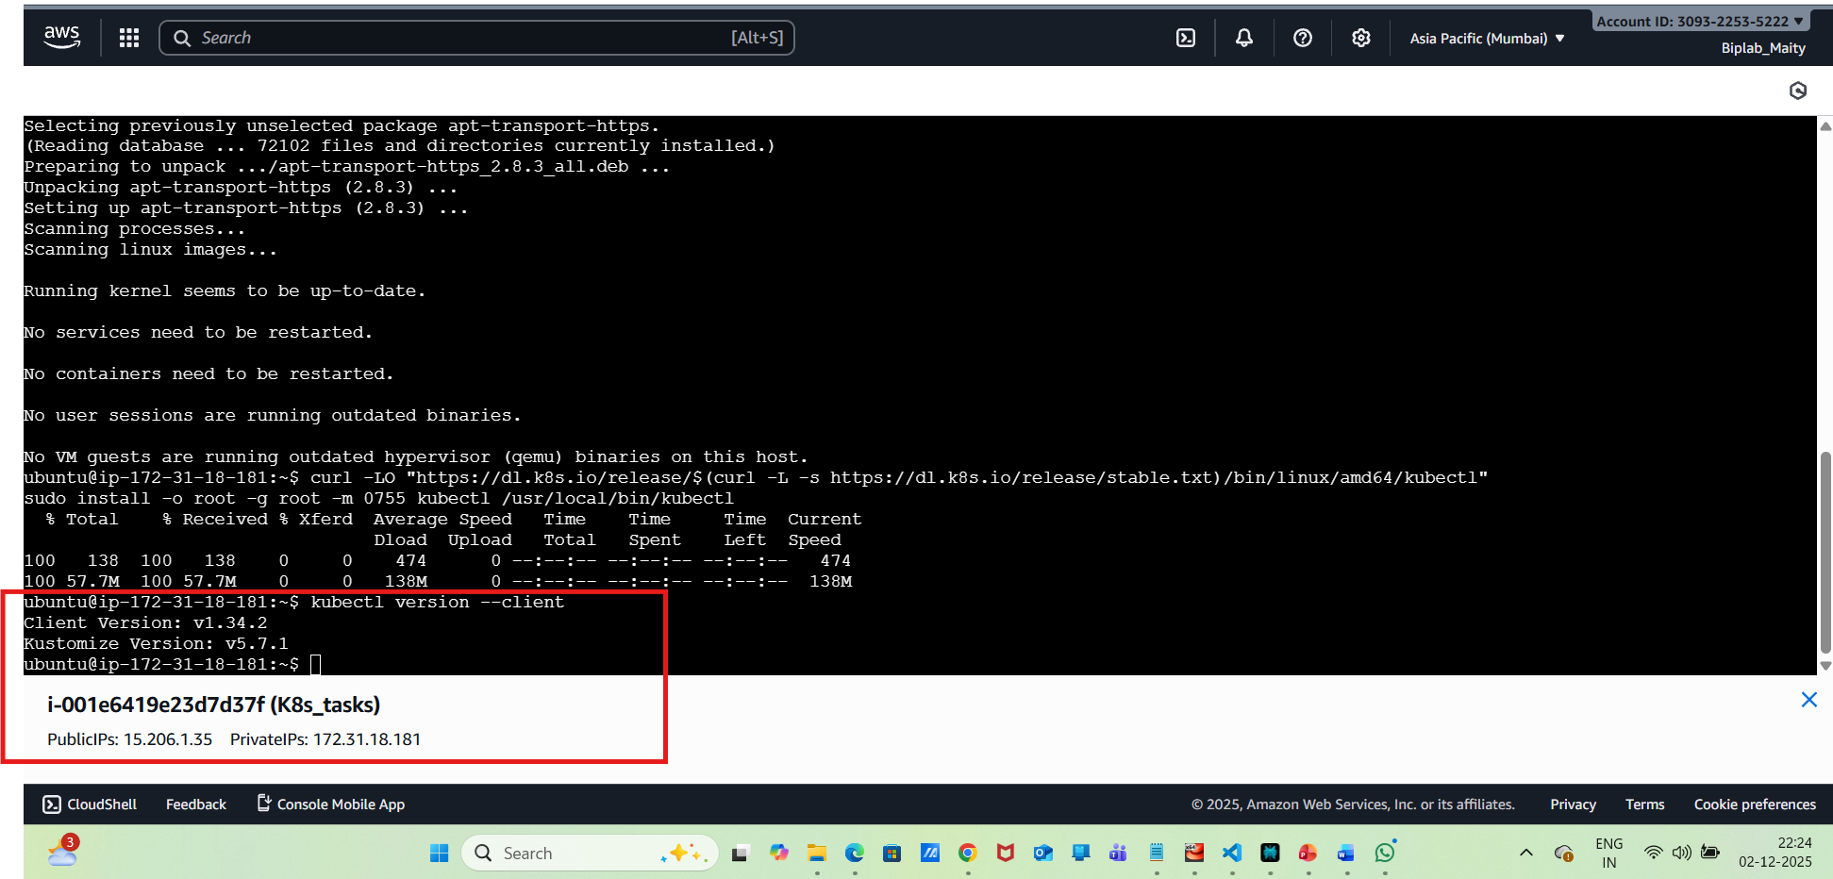
Step-4:Install Minikube using the below command

curl -LO https://storage.googleapis.com/minikube/releases/latest/minikube-linux-amd64
sudo install minikube-linux-amd64 /usr/local/bin/minikube
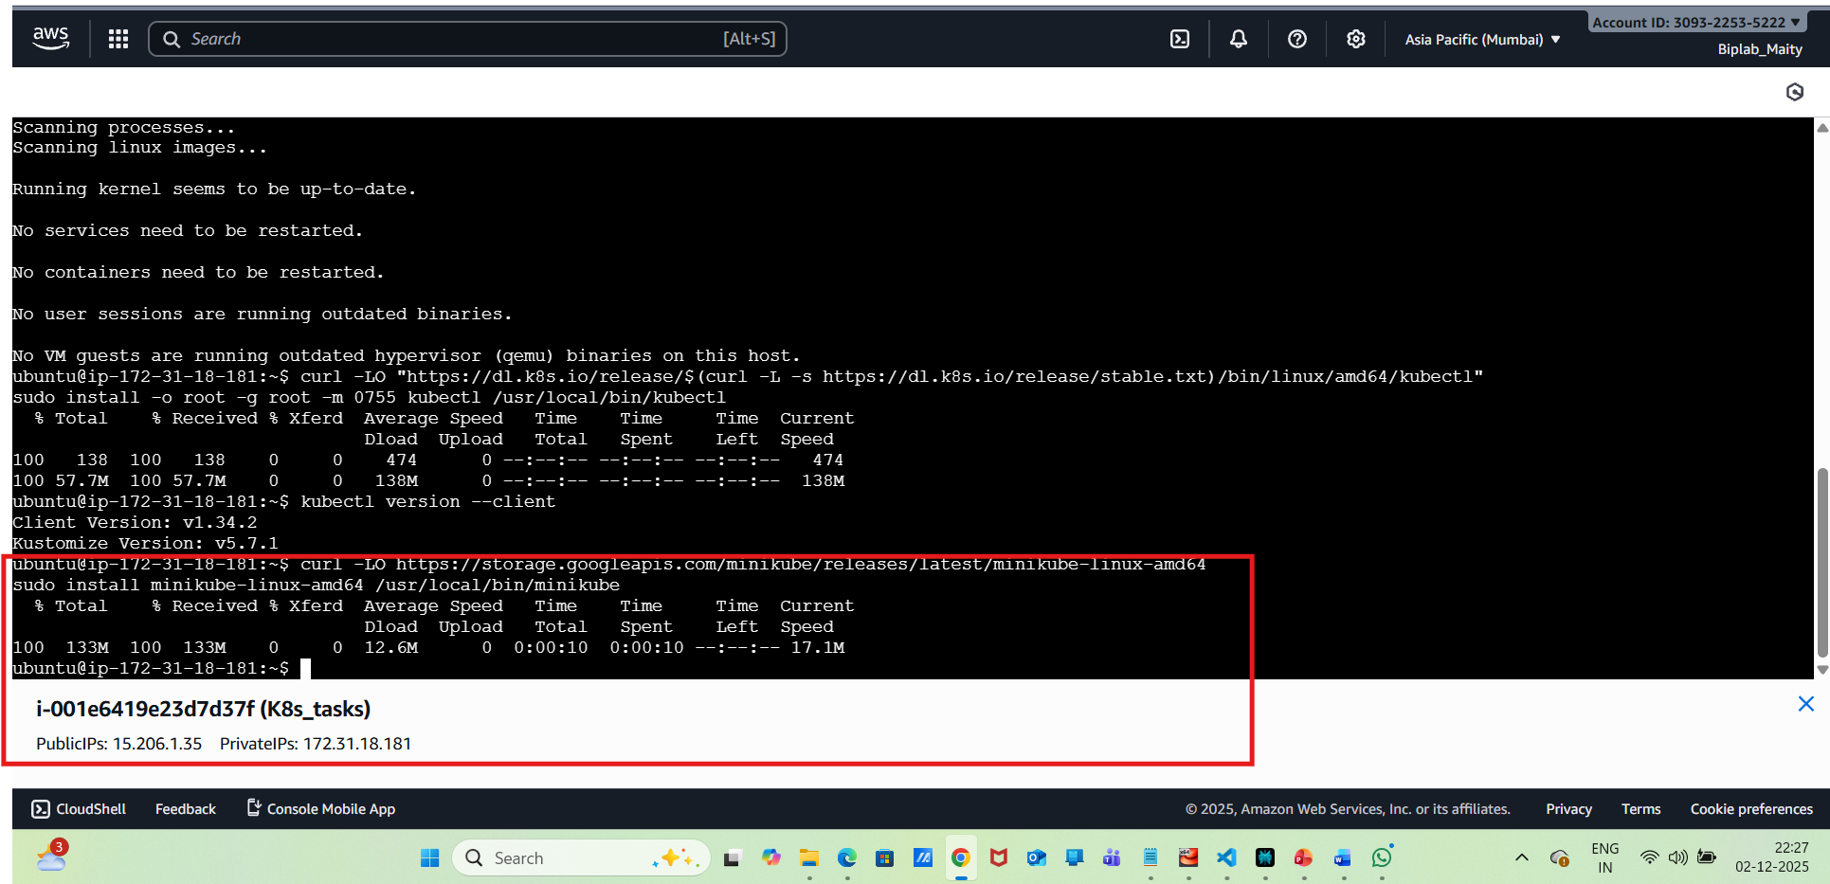
Step-5:Start Minikube using the command below on the EC2 instance

minikube start --driver=docker

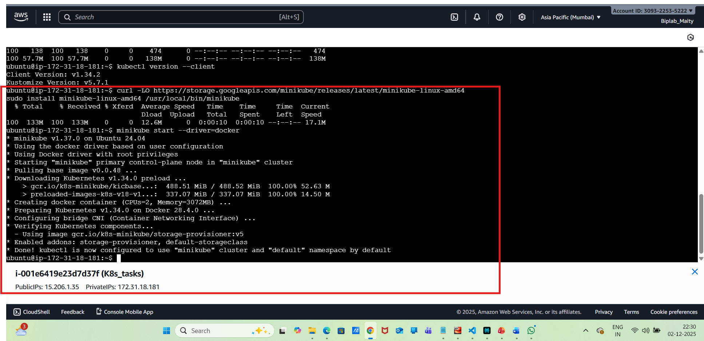
Step 6: Verify the nodes
kubectl get nodes

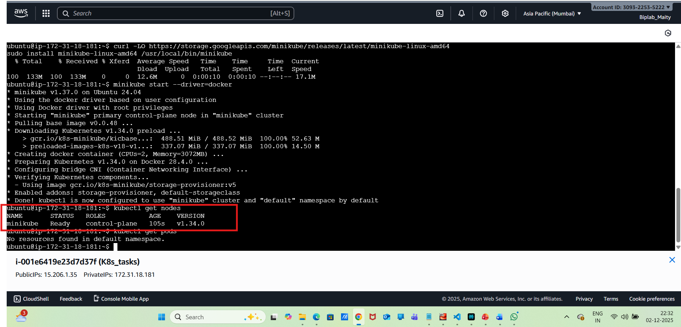
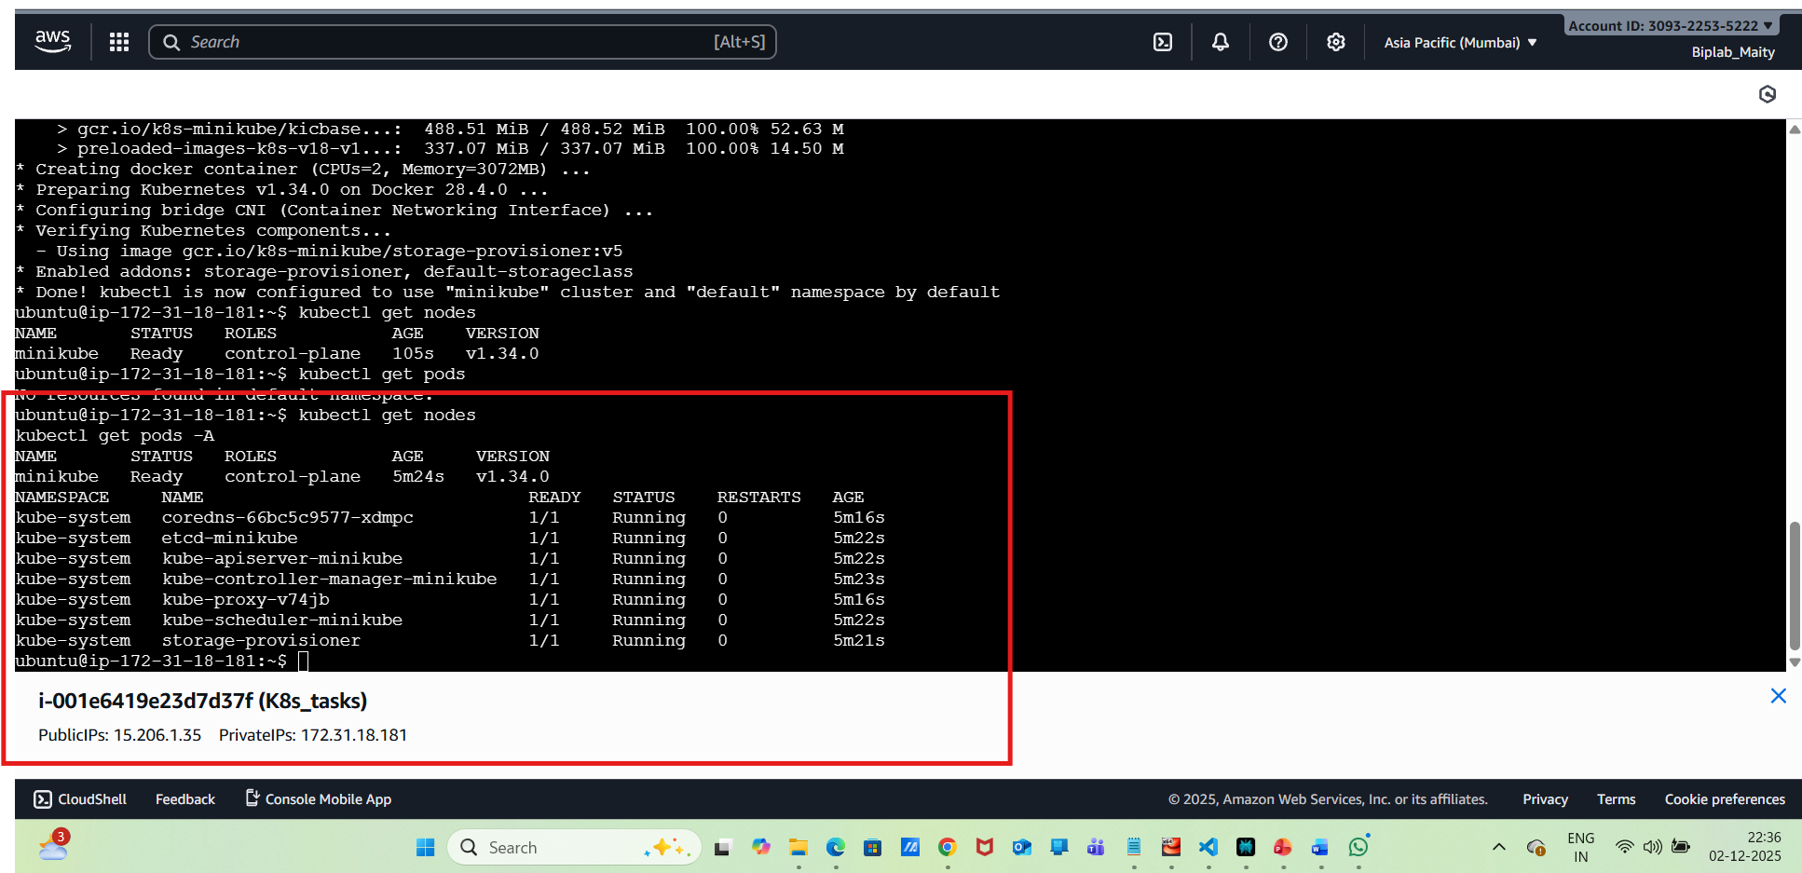
Step-6:Creating Namespaces in Kubernetes
kubectl create namespace dev
kubectl get namespaces
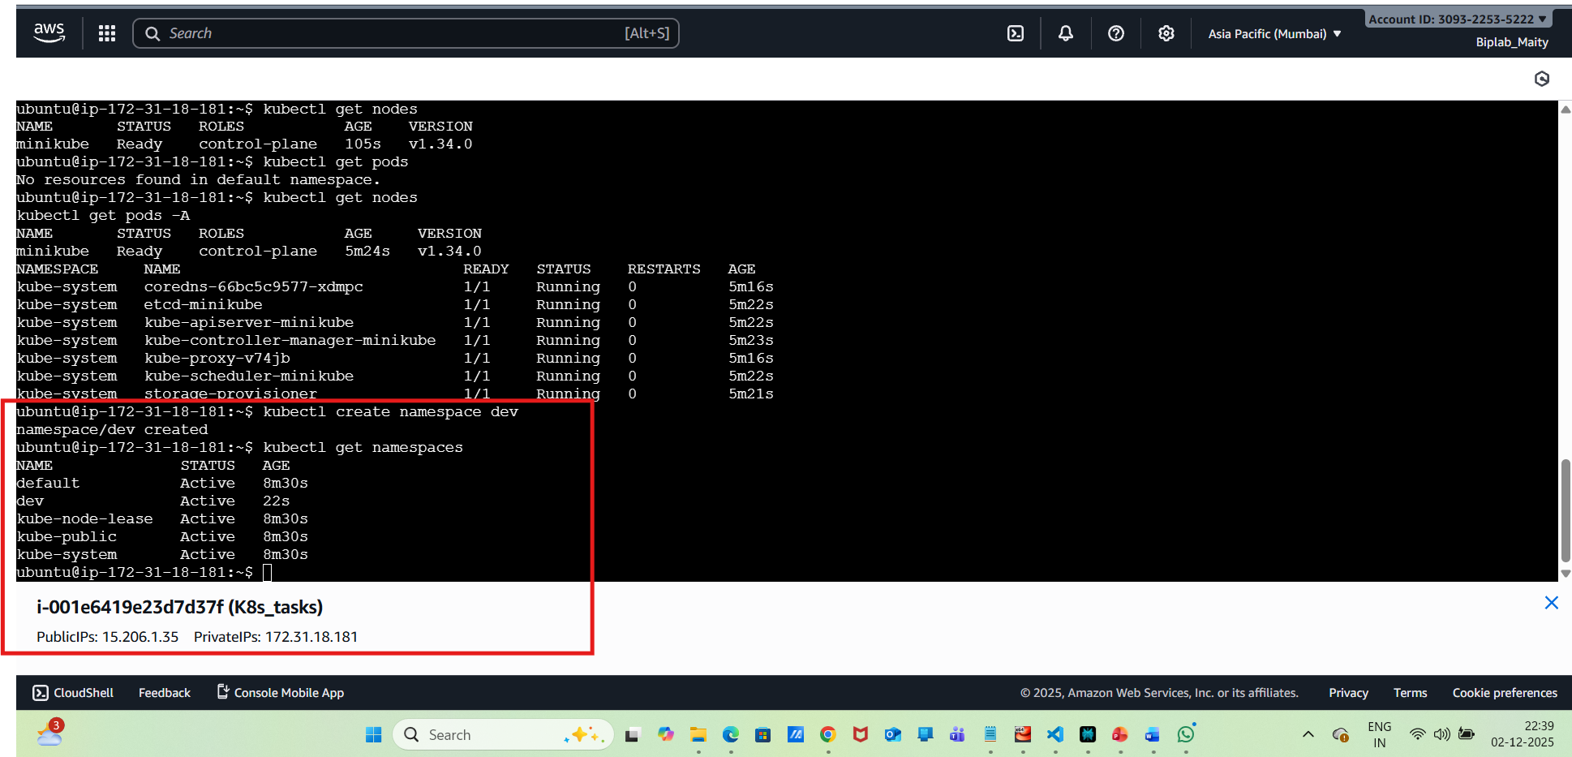
We can also create a namespace using YAML file

vi namespace.yaml
Then, do insert mode and paste the below content
apiVersion: v1
kind: Namespace
metadata:
name: my-application-production-namespace
labels:
environment: production
application: my-application
team: backend-devs
annotations:
description: "This namespace is dedicated to the production environment of the 'My Application' service, managed by the backend development team."
owner: "backend-devs@example.com"
cost-center: "IT-PROD-001"
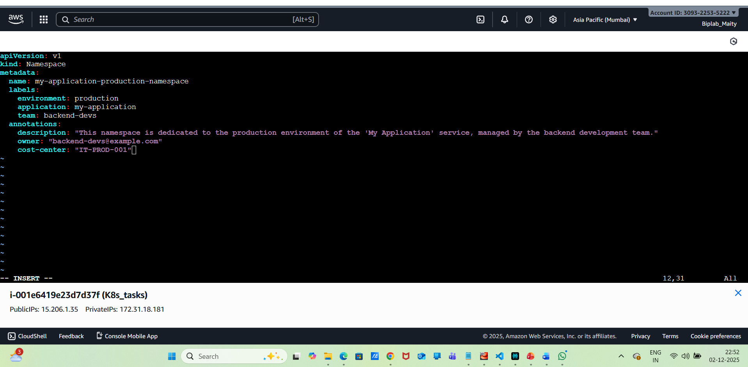
Then apply the namespace
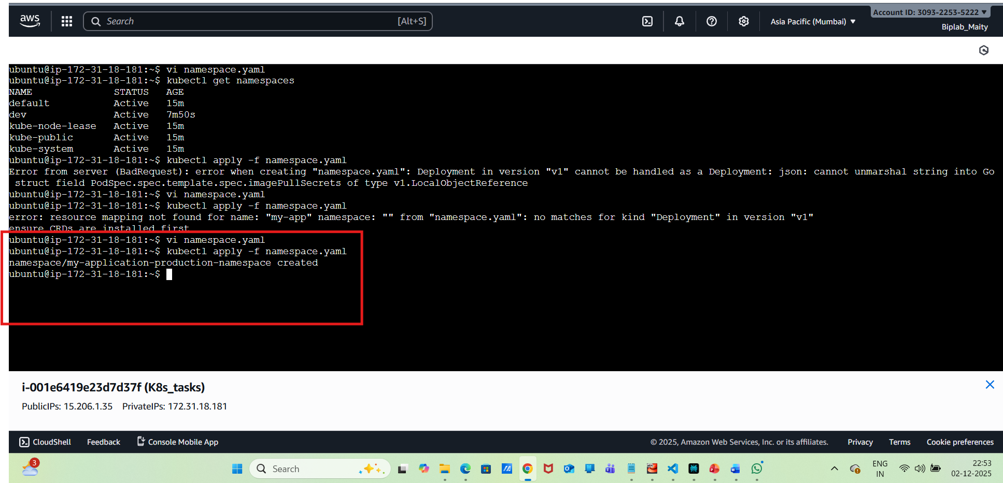
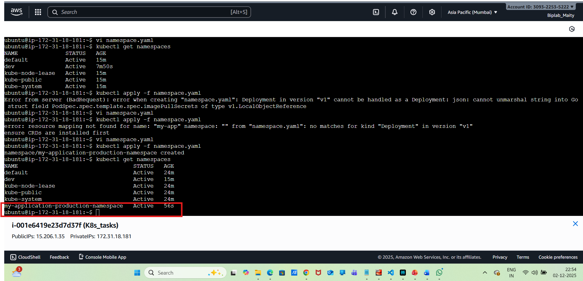
Delete namespace:
kubectl delete namespace dev
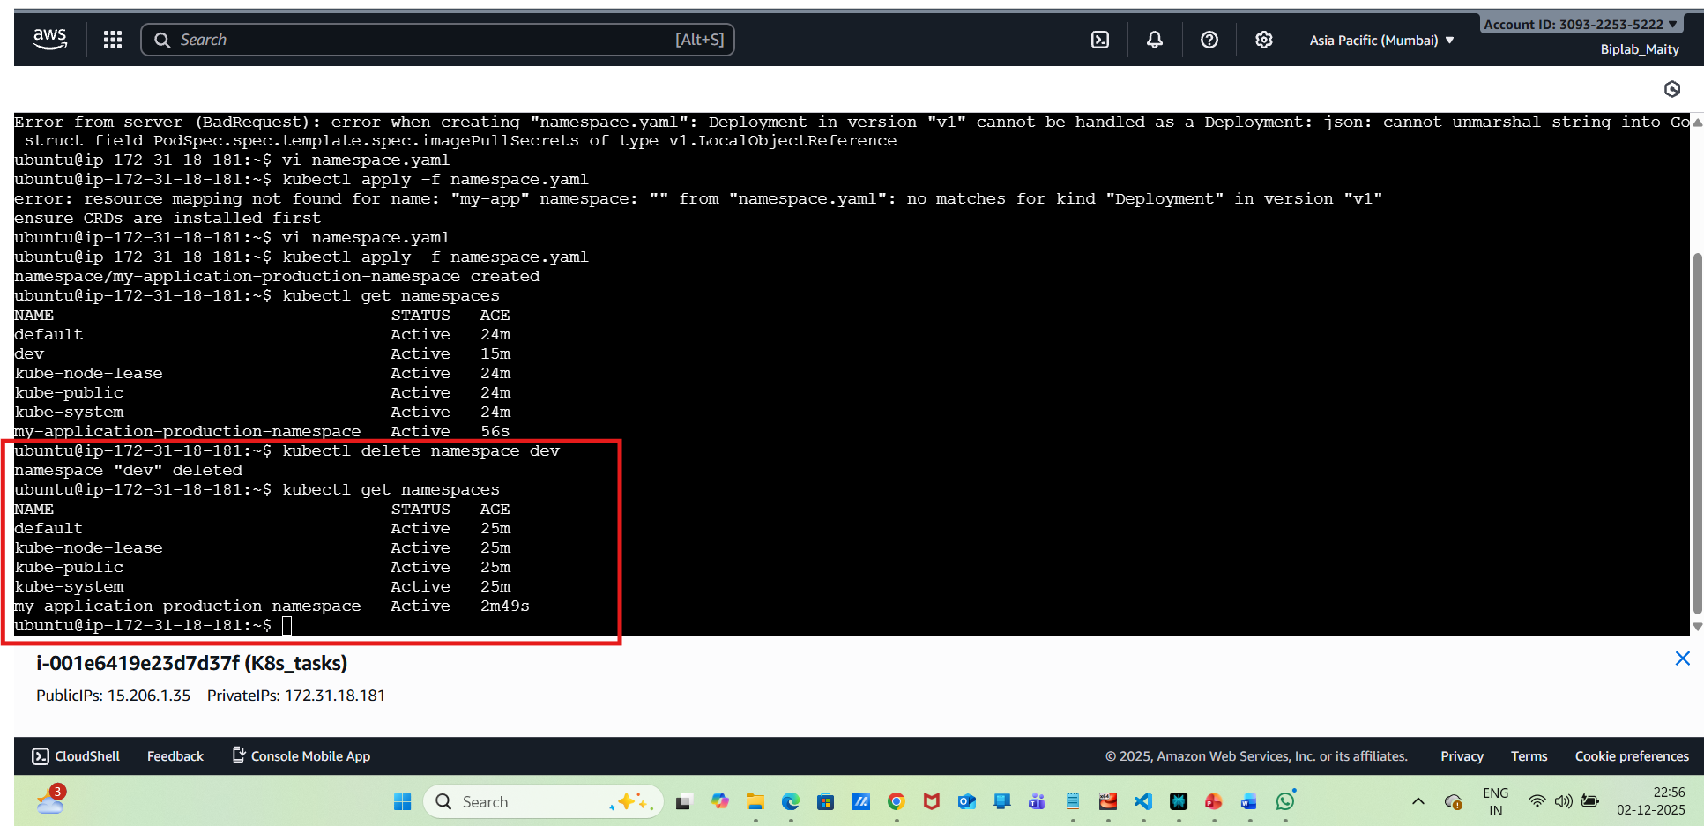
Switch Namespace:
we need to check the current context via the following commands
Check current context:
kubectl config view –minify
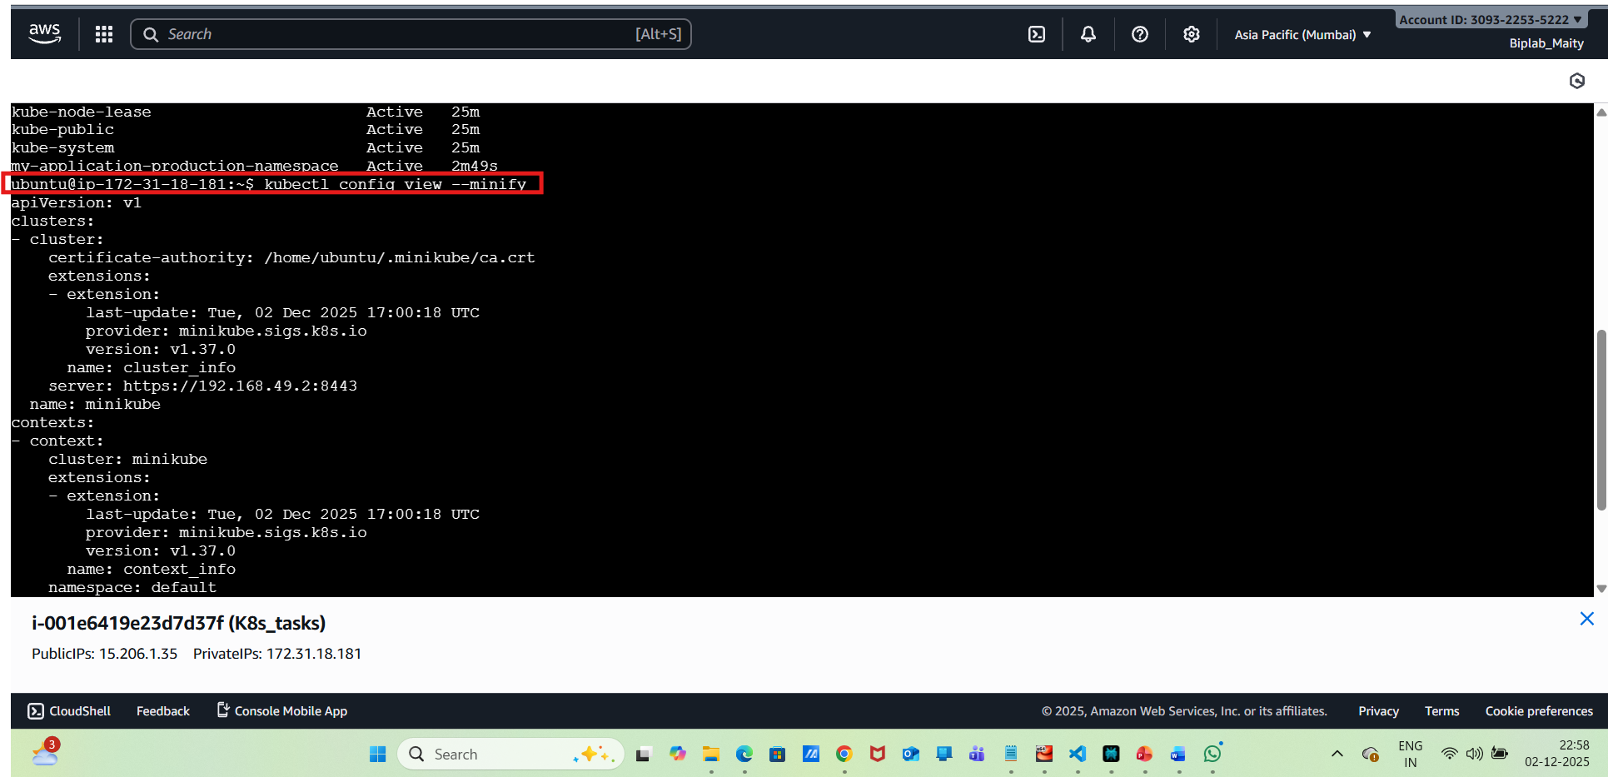
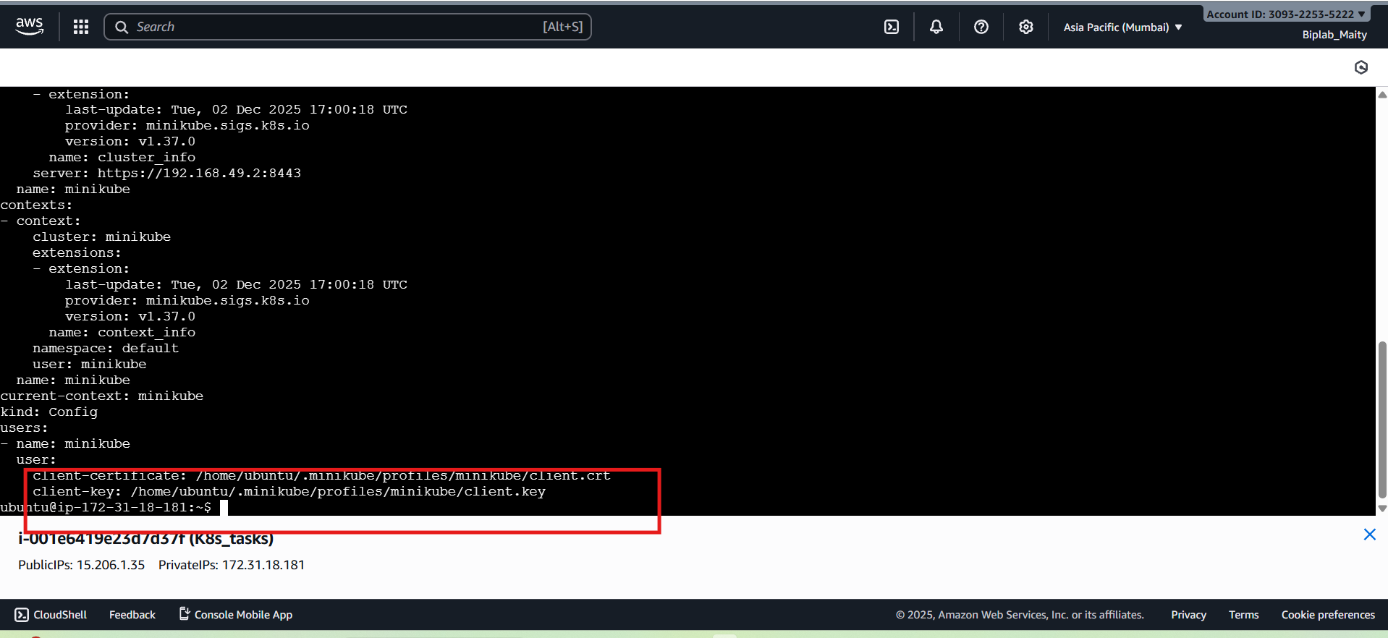
then set the namespace like below command :
